**CM1605 Web Technology**

**Tutorial 5**

The aim of this tutorial is to make use of JavaScript variables, arrays, and if/ else statement by translating the statements written in English into lines of JavaScript code.

This is an individual exercise. You may use any text editor (Notepad, Notepad ++) to create the HTML pages and any Browser application (chrome, IE, firefox etc) to run the web pages.

Note: **Use proper indentation, comments and proper naming conventions for variable naming where applicable**.

**Task**

You could use an ***embedded JavaScript File*** to create the below exercise.

1. Your page should consist of a simple maths game.
2. Using JavaScript, prompt the user to answer 5 maths questions of your choice (e.g. 12 x 6, 26 - 7, etc. ) You should prompt the user 5 times with a different question each time.
   1. You could do this as For example, if your first question is "8 + 7 = ... ",
3. Record the answers and compare them to the correct answers.
4. After each answer or once the user has answered all 5 questions, display on the page each question, the users's answer and a message saying whether the answer was correct or not.

Use the following statement to print the outcome-

document.write("<p id='correct'>Your Answer to question 1 is correct</p>");

document.write("<p id='incorrect'>Your Answer to question 1 is incorrect</p>");

1. In case of incorrect answer, also display the correct answer in a different colour or using a different font type or style. You will use CSS classes for this in an embedded Cascading Style Sheet. You will declare rules for 2 classes: correct and incorrect as follow. Feel free to add more CSS to improve the look and feel.

#correct{ }

#incorrect{ }

See the images below to get an idea of the sequence

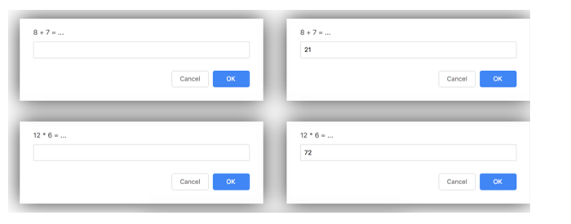



**Task 2**

1. Improve the same simple maths game, but this time you should use JavaScript to generate the questions using random numbers.
   1. hint 1: x = Math.floor(Math.random()*101); will generate a random number between 0 and 100
2. Select operators randomly(+,*,-) for each equation
   1. hint 2: Use an array of operators where a random index can be selected.